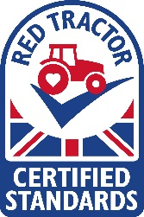
VISITOR RECORD
Date of visit | Time of arrival | Name | Company | Contact number | Last contact with livestock of the same species as on this farm | Sign to confirm that you are not suffering with an enteric illness

June 2019
Reviewed Oct 2020

